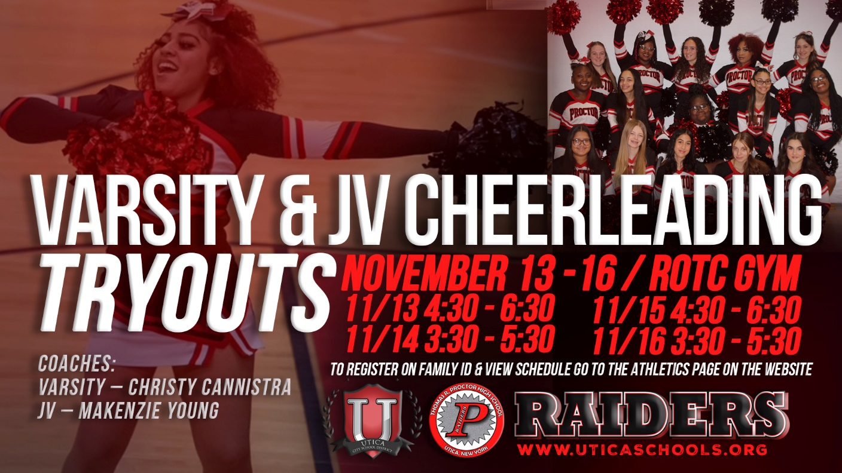
VARSITY & JV CHEERLEADING
Tryouts:
Monday through Thursday
November 13th - November 16th
11/13 4:30 - 6:30
11/14 3:30 - 5:30
11/15 4:30 - 6:30
11/16 3:30 - 5:30
ROTC GYM
Sign up on Family ID:
https://www.uticaschools.org/departments/athletics/family-id-instructions

