Senator James H. Donovan Middle School
Yearbook Order Info
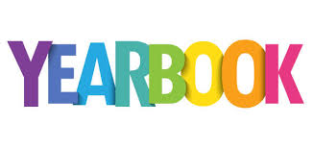
When: On sale now, thru April 3rd
Where: Online. Limited number of books may be available for sale at school in June. Please note, the only way to guarantee a yearbook is to place your order online. Last year, we sold out of additional books in a few days.
Cost: $30 plus tax
How:
OPTION 1
- Go to the link http://jostensyearbooks.com/?REF=A09896748 (also found on school homepage)
- Click on ORDER MY YEARBOOK
- Complete the student information. Press NEXT.
- Review your order, then add to Your Cart.
- Finish your order by Checking Out!
OPTION 2
- Go to jostensyearbooks.com.
- Click on BUY YEARBOOK
- Type in Senator James H Donovan Middle School
- Complete the student information. Press NEXT.
- Review you order, then add to Your Cart.
- Finish your order by Checking Out!

